Council Agenda item #1: Roll Call
The Caribou City Council held a City Council meeting, Monday, April 24, 2023, in the Council Chambers with the following members present; Mayor Smith, Deputy Mayor Boma, Councilors Bagley, Goughan, Morrill, Theriault and Willey.
Manager Thompson was present for the meeting.
Department Managers Lisa Plourde (Housing Director), Kenneth Murchison (CEO/Zoning Administrator), Dave Ouellette (Public Works Director), Michael Gahagan (Police Chief), and Carl Grant (Finance Director) were present at the meeting.
Melissa Lizotte of the Aroostook Republican covered the meeting, and it was broadcasted via Spectrum and YouTube.
Council Agenda Item #2: Invocation/Inspirational Thought
Pastor Troy Heald offered the invocation.
Council Agenda Item #3: Pledge of Allegiance
Mayor Smith led the Pledge of Allegiance.
Council Agenda Item #4: Public Forum
There were no comments made by the public.
Council Agenda Item #5: Minutes
a. Regular City Council Meeting – March 27, 2023
Motion made by Councilor Willey, seconded by Deputy Mayor Boma to accept the minutes from the March 27, 2023, meeting as presented.
Roll Call Vote: D. Bagley – Yes, C. Boma – Yes, R.M. Goughan – Yes, J. Morrill – Yes, J. Theriault – Yes, L. Willey – Yes, J. Smith – Yes. (So voted)
Council Agenda Item #6: Bid Openings, Awards, and Appointments
a. Employee Milestone Recognitions
The City of Caribou is recognizing milestone anniversaries this year.
Kenneth Murchison (Zoning & Code Enforcement) 5 years
Carl Grant (Director, Finance/HR/Tax Collection) 10 years
Corey Saucier (Sergeant, Police Department) 10 years
David Ouellette (Director, Public Works) 25 years
Lisa Plourde (Director, Caribou Housing Agency) 25 years
Denise Lausier (Deputy/Assistant, Tax Collection/Finance) 25 years
Doug Bell (Patrolman, Police Department) 35 years
Michael Gahagan (Chief, Police Department) 50 years
Jolene Blake (Ambulance Billing) Retired in May 2023, 23 years
Mayor Smith presented the employees with certificates for their milestone achievements and extended his gratitude to recently retired employees.
*Council Agenda Item #4: Public Forum – Mayor Smith allowed a resident to speak as they were a late arrival to the meeting.
Jordyn Rossignol, Caribou Resident & Business Owner
Ms. Rossignol came in to speak about the continuing struggles facing the Child Care industry. She explained some of the struggles her center is facing such as finances and staffing. She explained that there is a critical childcare issue, which causes problems for the working parents, because without childcare they are unable to work. She is urging everyone to get involved and to try to help to brainstorm ways to help the childcare industry.
Council Agenda Item #6: Bid Openings, Awards, and Appointments
b. Proclamation for Clerk’s Week
Mayor Smith read a proclamation to recognize April 30 through May 6, 2023, as Professional Municipal Clerk’s Week in the City of Caribou.
c. Proclamation for Hospital week for Cary Medical Center
Mayor Smith read a proclamation to proclaim the week of May 7th to May 13th as National Hospital week in the City of Caribou.
d. Public Works Bids
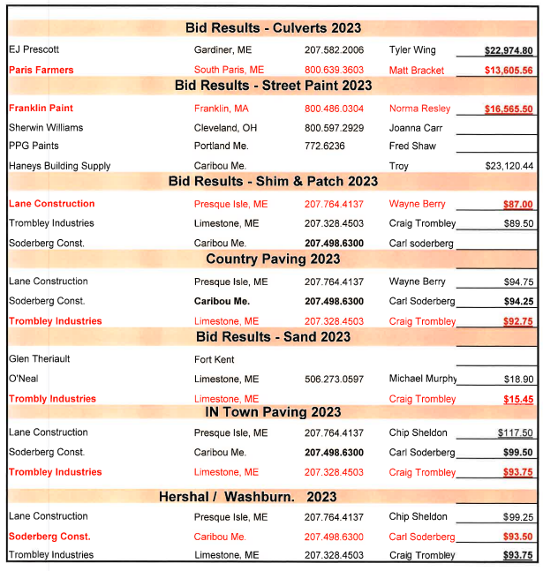
Dave Ouellette explained that he has recently placed several items out to bid and would suggest that the City go with the lowest bid in each category.
Motion made by Councilor Morrill, seconded by Councilor Willey to accept the bids per the recommendation of the highway department.
Roll Call Vote: D. Bagley – Yes, C. Boma – Yes, R.M. Goughan – Yes, J. Morrill – Yes, J. Theriault – Yes, L. Willey – Yes, J. Smith – Yes. (So voted)
e. Tax Acquired Property bids
Carl Grant (Finance Director) explained that with the current bid process the city received a bid on one property.
Motion made by Deputy Mayor Boma, seconded by Councilor Willey to accept bid of $6,000 to Carl Pinette for Map 15 Lot 67-B 903 Access Highway.
Roll Call Vote: D. Bagley – Yes, C. Boma – Yes, R.M. Goughan – Yes, J. Morrill – Yes, J. Theriault – Yes, L. Willey – Yes, J. Smith – Yes. (So voted)
f. Appointment of member to the Planning Board
Motion made by Councilor Morrill, seconded by Councilor Theriault to appoint Justin Staples to the Caribou Planning Board.
g. Appointment of members to the Caribou Development Committee
Councilor Morrill expressed his concern regarding the Caribou Development Committee. He explained that he has a couple of different concerns and thinks that the appointments should not be made until the ordinance is amended. His concerns are that there are 2 non-voting members, the City Manager, and the Councilor. He also expressed concern with the selection process should have only members that do not participate in Economic Development and be a neutral person.
Manager Thompson explained that if Council is thinking about making changes, then this is the time before sitting a committee.
Motion made by Councilor Morrill, seconded by Deputy Mayor Boma to revise Chapter 22 and make amendments to give voting rights to the Councilor and Manager, and to include that if on the board you can not be part of any economic development in Caribou.
Councilor Morrill & Deputy Mayor Boma rescinded the motion & second.
Motion made by Councilor Morrill, seconded by Deputy Mayor Boma to table the discussion until the next meeting.
Councilor Bagley stated that Councilor Morrill had a good point about voting rights, but the second part would be hard to accomplish.
Councilor Goughan stated that liaisons do not have to have voting rights.
Roll Call Vote: D. Bagley – Yes, C. Boma – Yes, R.M. Goughan – No, J. Morrill – Yes, J. Theriault – Yes, L. Willey – Yes, J. Smith – No. (So voted)
Council Agenda Item #7: Public Hearings and Possible Action Items
There were none scheduled for discussion.
Council Agenda Item #8: Reports by Staff and Committees
a. March Financials – Finance Director
Carl Grant (Finance Director) reviewed the March 2023 Financial Report.
Motion made by Councilor Morrill, seconded by Councilor Willey to accept the March 2023 Financial Report as presented.
Roll Call Vote: D. Bagley – Yes, C. Boma – Yes, R.M. Goughan – No, J. Morrill – Yes, J. Theriault – Yes, L. Willey – Yes, J. Smith – No. (So voted)
b. Manager’s Report
Manager Thompson reviewed the City Manager’s Report dated April 24, 2023.
Council Agenda Item #9: New Business, Ordinances and Resolutions
a. Request from the Planning Board – Rezoning Map 7 Lot 26 from I-2 to R-3
Motion made by Councilor Morrill, seconded by Deputy Mayor Boma to schedule a public hearing for May 22nd regarding rezoning Map 7 Lot 26 from I-2 to R-3.
Roll Call Vote: D. Bagley – Yes, C. Boma – Yes, R.M. Goughan – No, J. Morrill – Yes, J. Theriault – Yes, L. Willey – Yes, J. Smith – No. (So voted)
b. 2023 Spirit of America nominee process
Manager Thompson explained that the Maine Spirit of America Foundation became incorporated with the State of Maine in 1990 as a 501(c)(3) to establish a town volunteer recognition program. Every year the Spirit of America Foundation Tribute is presented in the name of 100+ Maine municipalities.
In the past the City of Caribou has selected honorees for the Maine Spirit of America tribute. If someone would like to nominate someone for the honor to reach out to City Manager Penny Thompson.
Council Agenda Item #11: Reports and Discussion by Mayor and Council Members
a. City Council Committee reports
i. Broadband Committee
Councilor Bagley stated that they met on April 10th and heard a proposal from Charter/Spectrum and that it should include a zero-cost share. He explained that they have not yet received a response from CUD and that another option is that the city could go with Pioneer on its own, which is not something that they are looking at, but that it is always an option.
He explained that they have received the BIG engineering study and will be meeting again in May. Councilor Bagley stated that once they reach their solution then the committee may be able to disband.
ii. Airport Committee
Councilor Bagley stated that they had an Airport Committee meeting on the 14th and that all members were present along with Manager Thompson and Dave Ouellette. He explained that they discussed the short-term rental project proceeding and that it would put future funding at risk where it is not aviation related.
They have also started the discussion of a possible partnership with Life Flight for a new tank. The City role would be to manage sales, and the public works department has expressed some concerns. They explained that the current tank still has several years of use remaining and that the tank should be left in place for the remaining six years. This will allow for time to put money into reserves for when the time comes to replace the tanks.
The committee has suggested different events to hold in the future such as a fly in event in May, the Caribou Community Garden Project, and a Grand Opening in June.
Council Agenda Item #12: Next Regular Meetings: May 8 & 22
Council Agenda Item #13: Executive Session(s) (May be called to discuss matters identified under MRSA Title 1, §405.6)
a. Discussion of economic development activities at the airport under MRSA, Title 1, §405.6.C
Motion made by Councilor Bagley, seconded by Councilor Willey to enter executive session at 7:32 p.m. to discuss economic development activities at the airport under MRSA, Title 1, §405.6.C
Roll Call Vote: D. Bagley – Yes, C. Boma – Yes, R.M. Goughan – No, J. Morrill – No, J. Theriault – Yes, L. Willey – Yes, J. Smith – Yes. (So voted)
Councilor Goughan excused himself from the meeting and did not stay for the executive session.
The Council exited executive session at 8:15 p.m.
No action was taken.
Council Agenda Item #14: Adjournment
Motion made by Councilor Bagley, seconded by Deputy Mayor Boma to adjourn the meeting at 8:15 p.m.
Roll Call Vote: D. Bagley – Yes, C. Boma – Yes, R.M. Goughan – Absent, J. Morrill – Yes, J. Theriault – Yes, L. Willey – Yes, J. Smith – Yes. (So voted)
Danielle Brissette, Secretary

